NZEYIMANA YVON MIRACLE 16TH MAY 2023

23707

WEBTECHNOLOOGY FINAL EXAM

Link: https://github.com/yvon78miracle/webtech.git

ONLINE EXAM refers to form f assessment that is conducted electronically through internet its allows people to register and complete their exam using device through internet

Its has requirements

1.USER REGISTRATION

USER INFORMATION:NAME,EMAIL,PASSWORD,TEL

USER ROLE:USER,ADMIN

Captche verification:to prevent automated registration

2.Account verification:Security,user account,account verification and integration

SO Depending on the exam requirement or insttitution policies there may be addition steps involved in the registration process .these can include paying exam fees,submitting neccesary document and providing other relevany information requested by the exam adminidtrator

The purpose of an online portal exam is to assess the knowledge, understanding, and skills of students in a particular subject or course through an online platform. Online portal exams provide a convenient and accessible way for students to demonstrate their learning without the need for traditional pen-and-paper exams or physical proctoring.

The purpose of online portal exam registration is to facilitate the organization, management, and logistics of conducting online exams. It allows students to officially enroll or sign up for a specific exam through an online platform or portal. Here are some key purposes of online portal exam registration:

Planning and schedule

Securitu and integrity

Communication and updates resource allocation

accommodation

DATA BASE

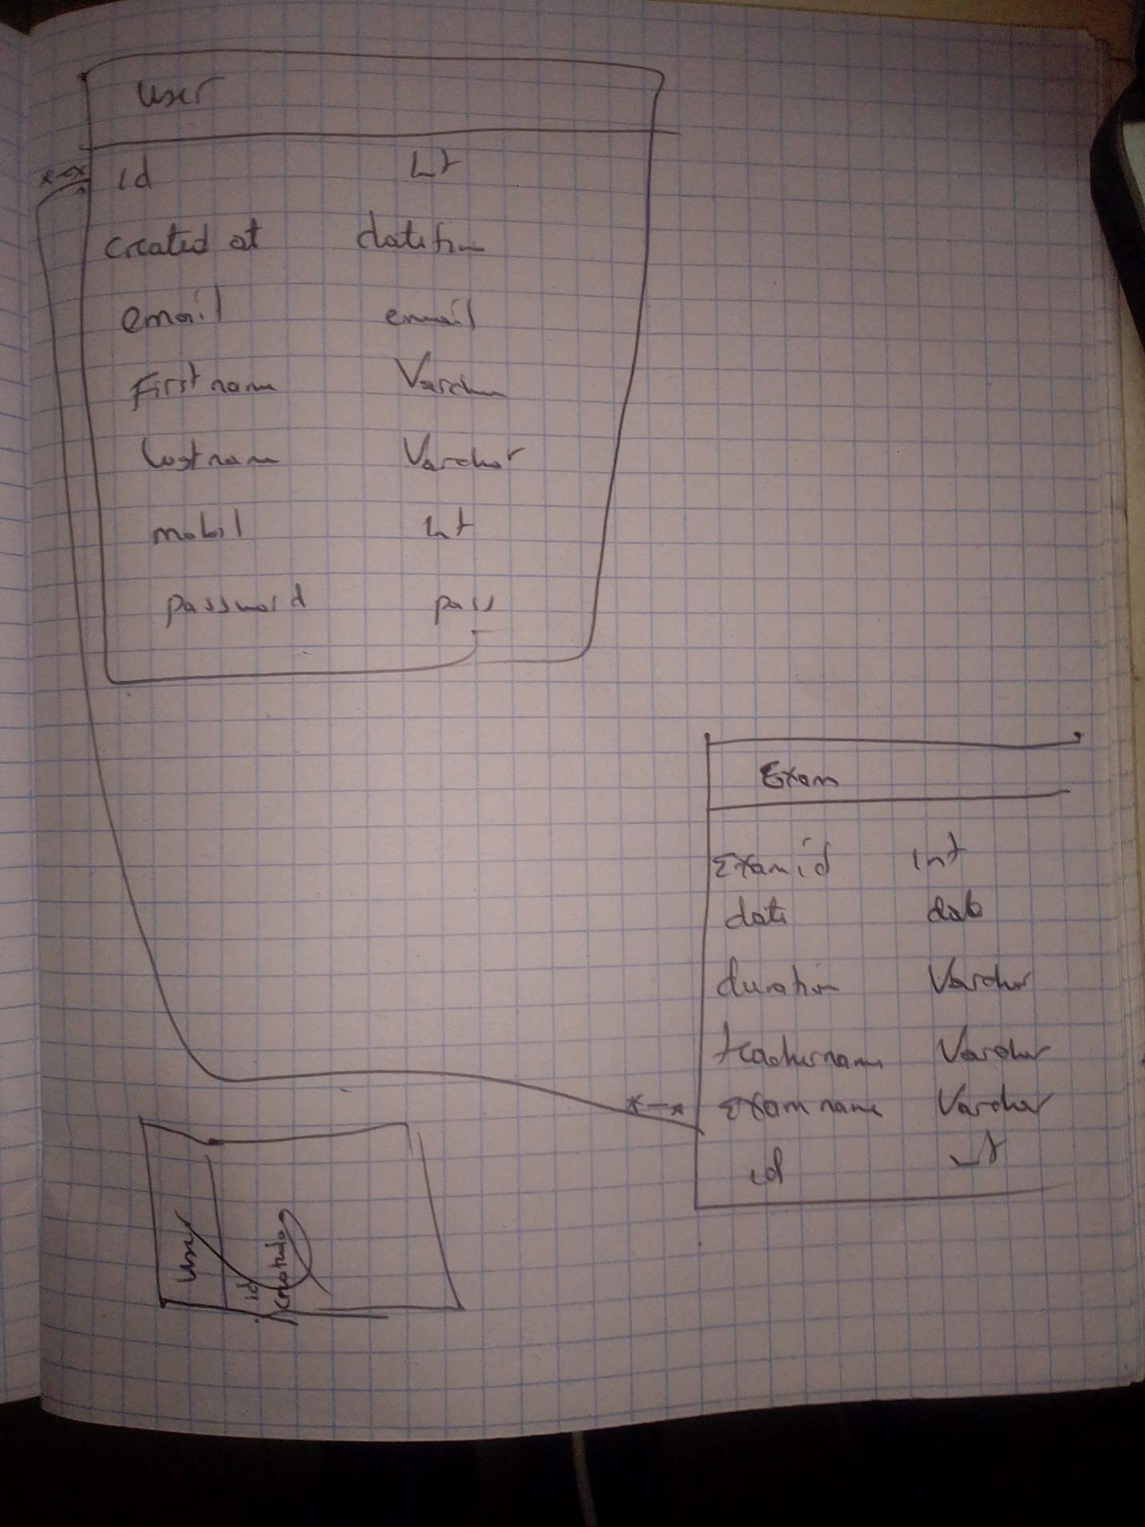

USER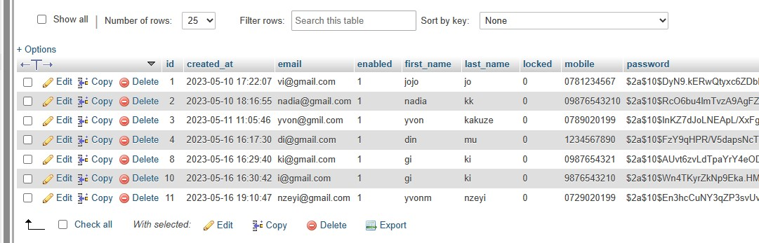

First us user or admin you may be at the home page where you can make clear legistration or signup and if you have arleeady have the account make login

HOMEPAGE



After you reach at home page you can make registration or login in orther to access the full information means that you must be the member of the account

LOGIN

REGISTRATION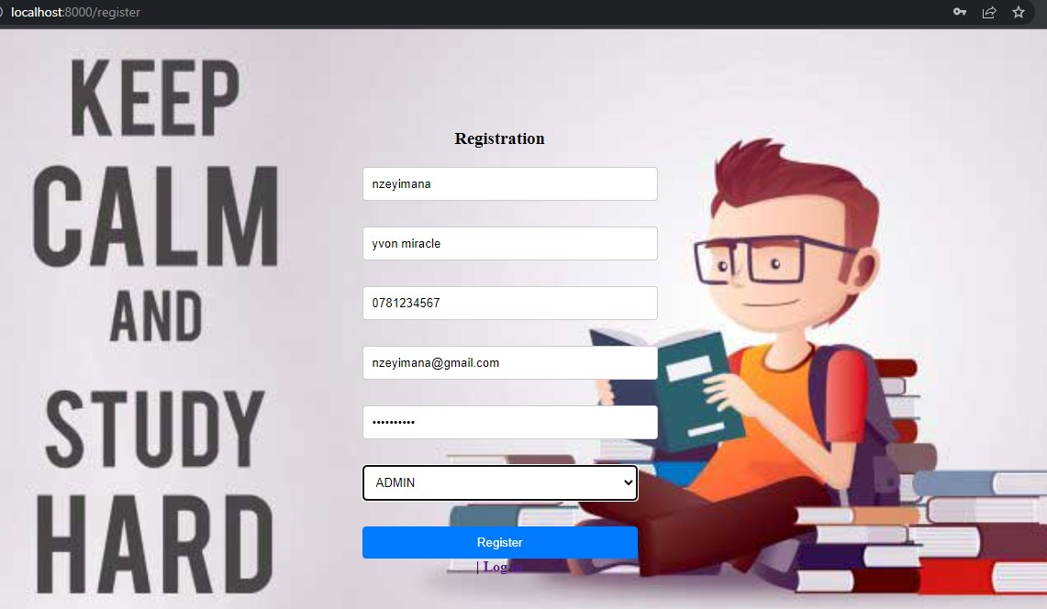

After registration you must be at the darchboard where you can access the exam or make the registration in order to be accepted to be able of the people who will be having the exam

DASHBOARD

So here we will have the registration of the user who will view the exam the time will be done and register the exam by the admin to put where and when will be registred

This will be ha[ppen by the ADMIN only

EXAM REGISTRATION DETAILS BY ADMIN



The ADMIN MUST VIEW the data that he puts about his things and also he must delete and edit about that things and the user will see only the updates that will happen

DISPLAY AND DELETE

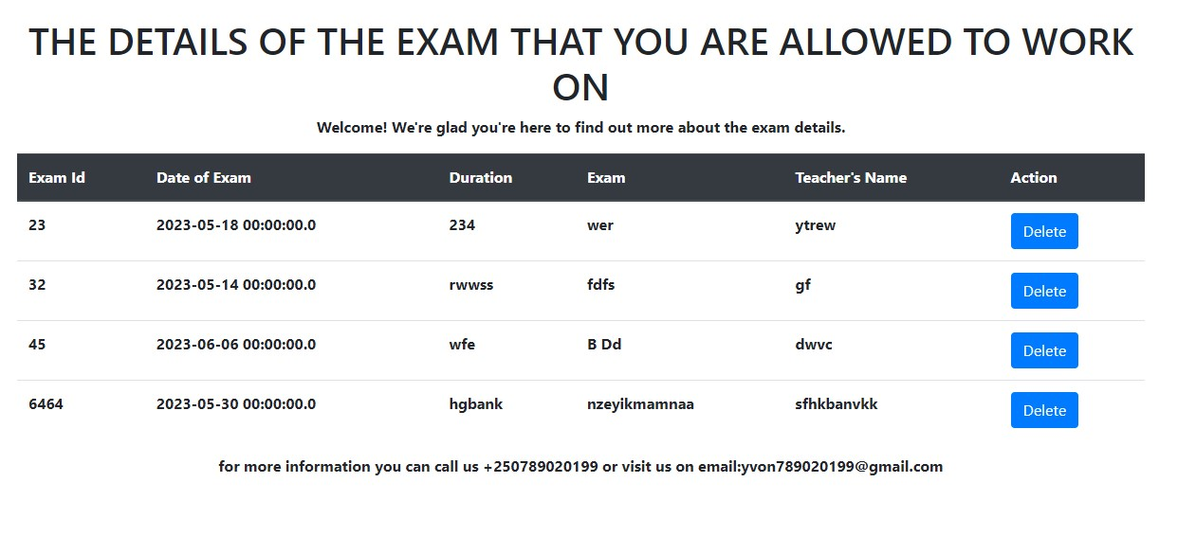

DELET

Here we will delete the people whose have primary key means that the delete will take all details about that id

Lets delete the one who having id 45 and 32

DELETE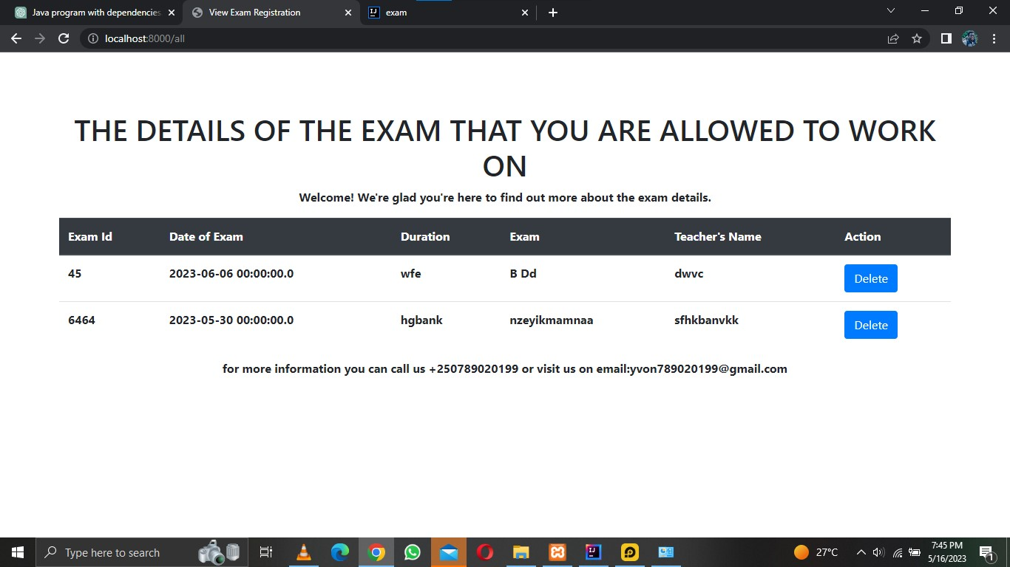

In implementation the service layer I was using the interface between user and data which means that user interface and my external services which ix xamp(database)

That contain the full logic performs to be process that fullfill the request received from presentation layer

First

I creat interface for the services

2.i,mplement service interface

3.repository interface and its implementation for those data eccess

IN summary online exam registration is the process where individuals interested in taking an online exam provide their personal information ,choose the exam they will wish to take,and complete any necessary steps to confirm their participation.

Implement the Controller Layer:

Thuis is component that hundles incoming request from the user interca,performers and return the appropriate response

So iwas control class and map it to the URL

2.configure the view resolver and mapping in spring config